STUDENT Joseph Roper

SALFORD CITY COLLEGE | FUTURE SKILLS

BTEC National Extended Diploma in Creative Media Production

UNIT 68: 3D ENVIRONMENT

Unit 68 – 3D Environment

# Idea Generation

For my evironment I thought of a few ideas as seen from the mindmap but overall I decided on creating part of a prison for my 3D environment. I then thought of what I could make with my current knowledge of 3D modelling from college and decided to create a small cell block with a closed off hallway. I then drew out an idea for how my evironment would look and added the different objects I wanted to be in my scene and annotated every model I would have to make as well as the textures I would need. I also made a few mockup drawings of how I wanted the room and hallway to look in my prison.

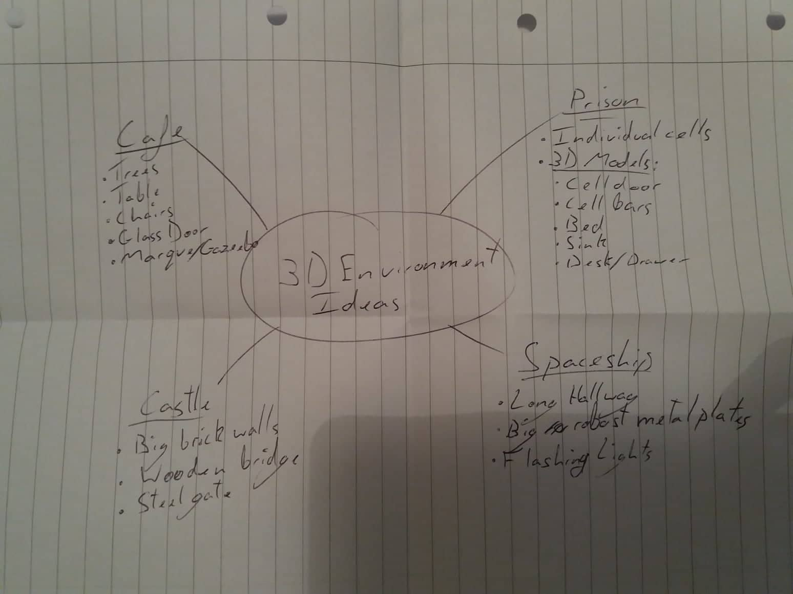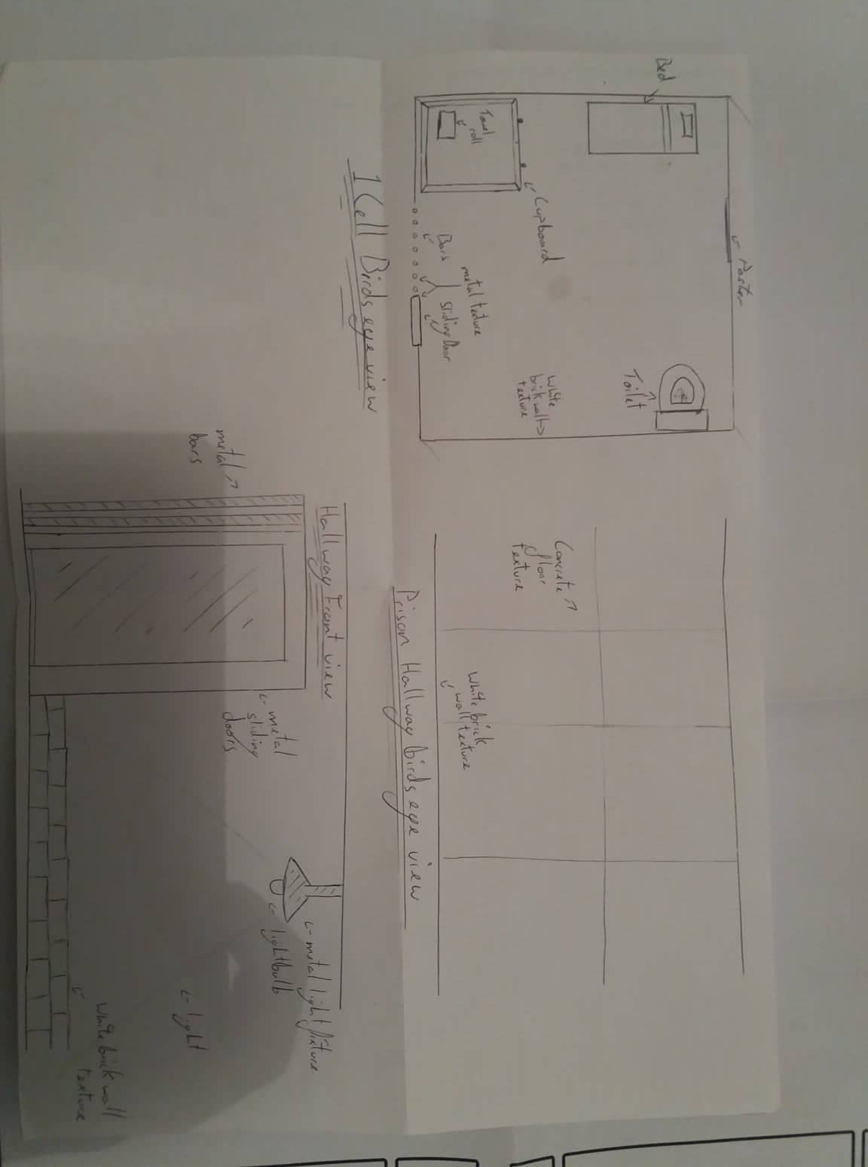

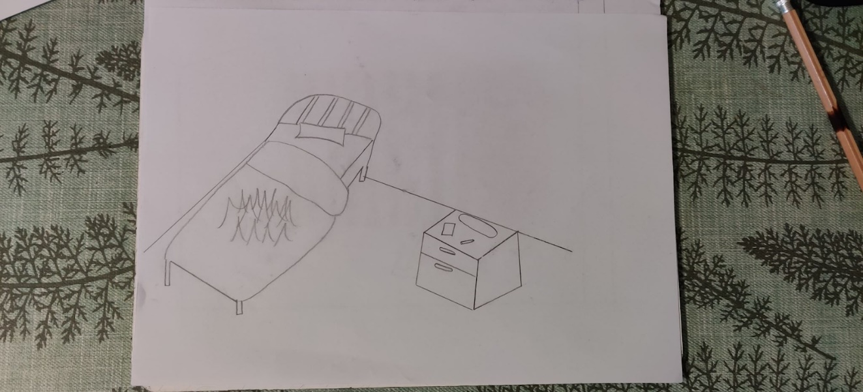

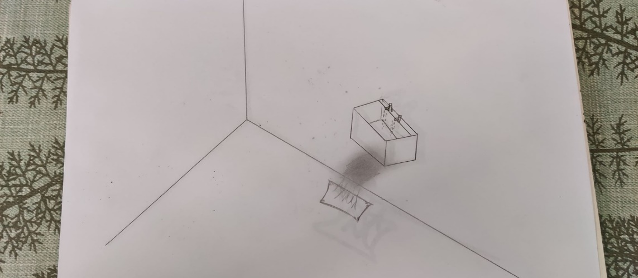

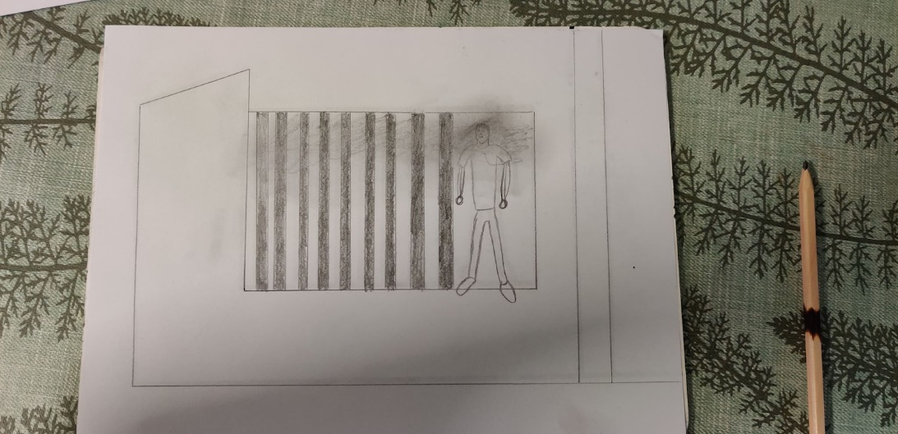

# Moodboard

For my moodboard I chose a selection of pictures from the internet of prison cells to use as a constant reference while modelling my environment. For example I kept checking the width between the bars in the pictures to make sure my own had the right proportions. I placed a picture from the show orange is the new black in my moodboard to remind me of the series and how that prison looked and the items you would find in it for example I didn't know inmates could have pencils, cooking equipment and buy things in a in-house store until I watched the series. Having the picture there made me start thinking about prison which helped for my project. On my moodboard I placed a selection of items I would have to model for my environment such as a single bed and a pillow. I also placed these items on my moodboard so that every time I looked at them I would think of other models to create and place in to my environment. I wanted my prison to be dim and gloomy therefore I chose dark and dreary colours for my moodboard. With a dirty white colour for the walls and ceiling. And then silver for the bars and other metal in the prison. The blacks and darkbrowns will be used for the floor and the inmates personal items. I first thought of making my environment and animation about a prison when I saw daredevil season 3 with the brilliant prison escape seen where daredevil had to fight through countless inmates and guards to escape barely alive because of this I modelled the escape door in my environment (top left picture) to look the same as the door daredevil first walks through to discover countless angry inmates and guards that I believe hints at the future of the escapee in my animation.

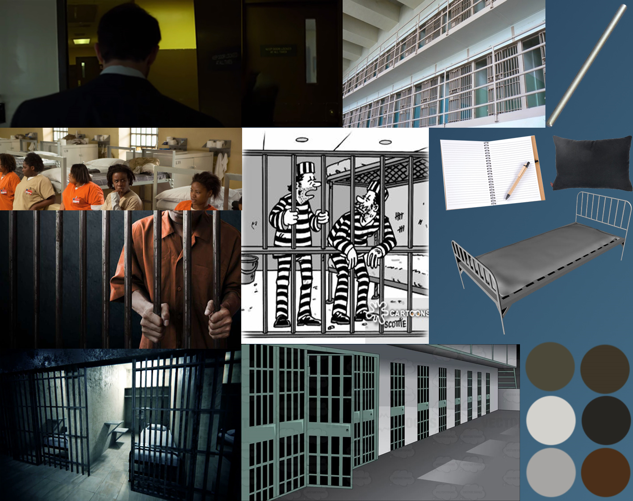

# Target Audience

The target audience for my environment and animation is for people who like the shows and movies referenced in my animation storyboard which are: Daredevil, Punisher, Orange is the New Black, Silence of the Lambs and Birdman of Alcatraz. This is because this is the media that I like and based my animation off. Another reason for this is because I will be judging the animation meaning the animation I make will be something I like to watch such as Daredevil. My environment and animation will both be for all ages as there will be no swearing or violence and sexual references or objects in my environment and animations. There will be no issues with copyright and ethical considerations for my animation and environment as all the models were made by me and I will be using free to use music and sound in my animation. Although this would not matter as this is a student project for educational purposes so I could use copyrighted products. I will also not have to watch out for other ethical considerations such as libel law (damaging someone's reputation) as my animation will be a piece of fiction with nameless characters within it. Discrimination will not be an issue as I will not be targeting any groups in my animation.

# Textures

## Metal Texture

To start I changed the shader from Blinn to Multi-Layer.

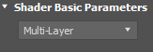

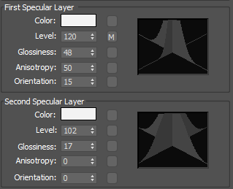

I then went down to the reflective map and added the mask map. I then clicked on map and added raytrace.

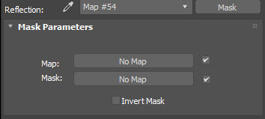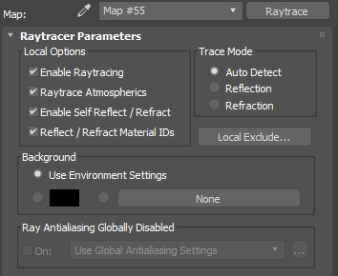

I then went up a layer clicked on mask and added the falloff map.

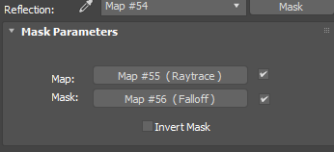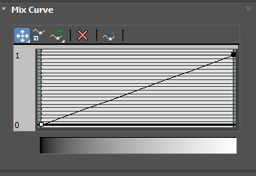

You can change the mix curve by moving the left box up and down to control the reflectiveness of the object. I clicked on the diffuse colour and changed it to be darker to represent the colour of metal more.

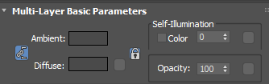

## Glass Texture

To make the glass texture I went into the material editor selected an empty ID changed the diffuse colour to a light blue and then made it slightly transparent.

## Prison Floor Texture

I did this by clicking on my object selecting edit poly and then I selected the faces of my floor changed the ID of all of them then I clicked on material editor selected the ID I set the floor too and started adding the textures to my floor. I added the diffuse map which is the normal floor texture and set that to 100. I then added the bump map which is the purple one this makes the floor look 3D by adding thickness to the floor I set this to 130 as if it was any higher it would make the floor stand out and look abnormal. I then added the specular level map which is the darker one and set this to 100 this makes the floor look more rugged. I then turned on the texture however the floor was offset so I selected the floor and added the modifier UVW Map clicked on box select, view align and then selected fit after that I rendered the image and the floor texture was aligned.

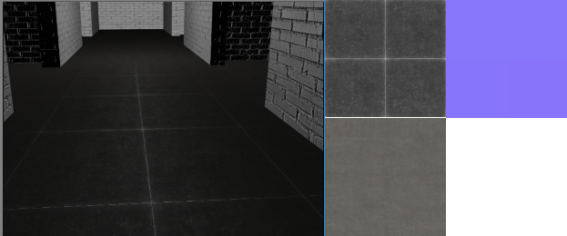

## Prison Wall & Ceiling

To texture the floor and ceiling of my prison I used the same method as I did to texture the floor however I used different material ID’s and textures.

For the ceiling texture, I just placed it on a diffuse map.

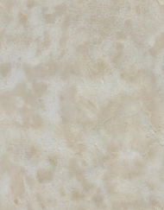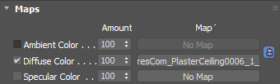

For the wall texture, I put the map on the diffuse colour set to 100, on the specular level set to a 100 which makes the texture more reflective and lastly on the bump map set to 30 which will make the wall look slightly grainy like real bricks.

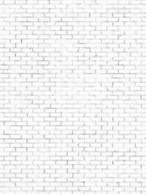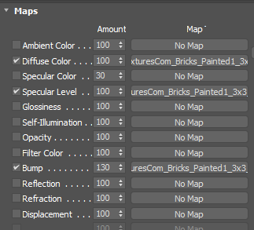

# 3D Models

## Prison Frame

I started modelling my final project, by creating a hallway and adding rooms from there. I did this by creating a box to make a cuboid. I then added the modifier edit poly and started selecting the faces of my cuboid that I wanted to turn into the rooms I then inset the faces using the inset tool on edit poly. I then inset the face to make it hallway sized and then extruded the face using the extrude tool in edit poly. I extruded it slightly to create a hallway and inset the face outward to be the size of the room I want, I then extruded the face again to be the size of my rooms. I then selected the right side of the model and moved it to the left so the rooms and hallways were straight and not angled, I then did the same process with the other side of the model. Lastly, I selected every face of the model and flipped it so that when I added textures later they would appear on the outside of the model.

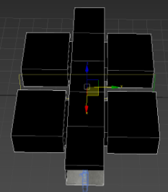

## CCTV

To create the CCTV camera, I first made the panels that would connect to the wall for this I made a box made it square and set the thickness to be just nearly flat. I then added cylinders at each of the corners and then added boxes within the cylinders then added the modifier I edit poly selected the side edges of the box and then used the chamfer modifier to make the box resemble a screw fitting. I then added another panel in the centre of the first one using the same method. I then created a box and used the same method as before to chamfer it to resemble the pole that is meant to hold the camera. Then I copied the chamfer box and rotated it 90 degrees and then copied that made it smaller and moved it up a bit. I then created a cylinder to act as where the camera would rotate, I then copied one of the chamfer boxes from earlier enlarged it and placed it on top of the cylinder to act as the body of the camera. For the camera lens, I created 3 cylinders and placed them on top of each other and added the glass texture to the one in the centre. I created the red light last for this I placed a variant of the cylinders which is pill-shaped onto the camera added the edit poly modifier selected the faces of the light I didn't want and deleted them, I then made the light red using the material editor and turned up the transparency of the colour to make the light slightly transparent. To finish of this model, I added the metal texture to the camera body and panel to make it look more realistic.

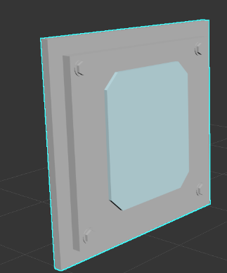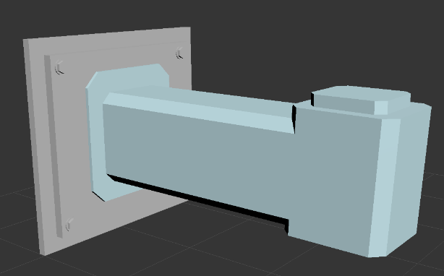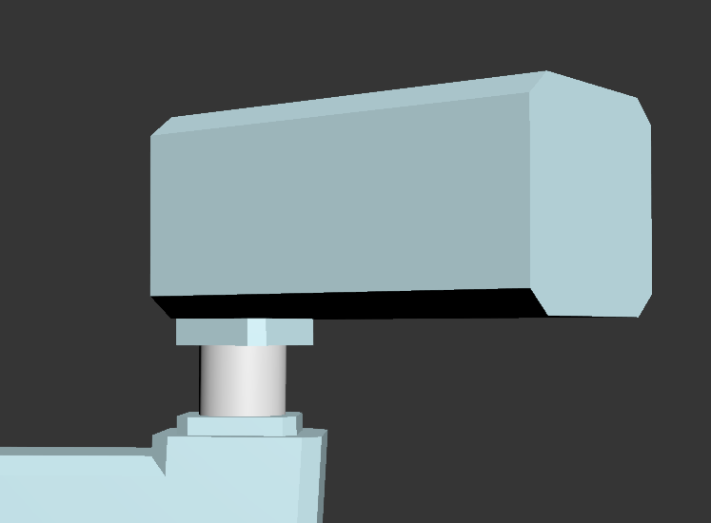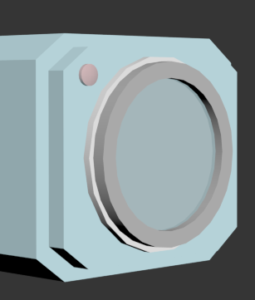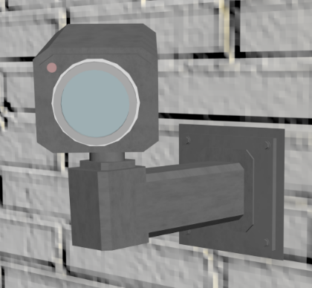

## Door

For this door I decided to go with a slightly different modelling method by placing the picture of the door on a plane in my scene and model the door in front of it, so I would have a constant reference for what I was modelling. The door is made up a box altered to be the shape of the reference image, the for the metal bar I used the line tool to draw the same of it then changed the thickness using the edit poly modifier. For the ventilation at the top of the door I used boxes and just altered the size and rotation of them too match the reference picture. I then selected the everything I had created and used the modifier UVW wrap to wrap the picture of the door around the model that I had created. For the bit of glass, I created a box and added the glass texture to it.

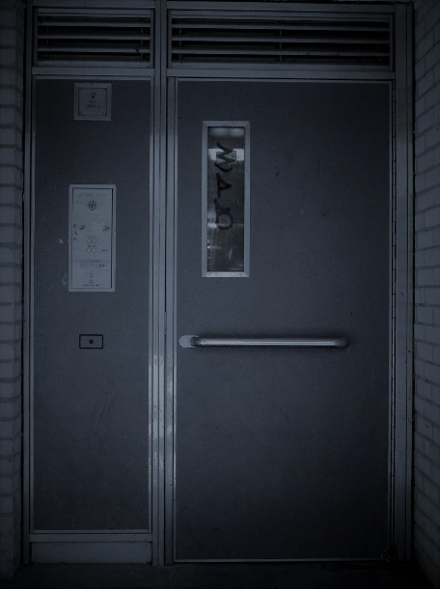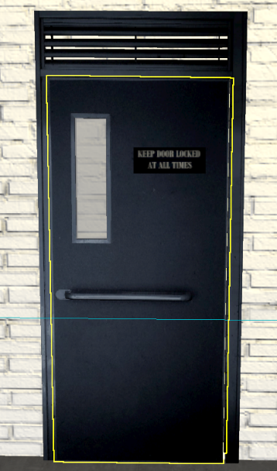

For the sign I got inspiration from the prison breakout scene in Daredevil season 3 where on the prison doors it had this sign too recreate it I used an unconventional method and went into word added a blue box and typed the words “KEEP DOOR LOCKED AT ALL TIMES” and placed them into the blue box and changed the font to suit a prison. I then used snip to get an image of the sign then I opened the image and used the windows photo editor too apply a filter on the image to make it match the door. I then flipped the image as when I applied the image to a box in 3ds max it would appear flipped, so I flipped the original image and it faced the correct way when it was on the box. To create the sign model in 3ds max I placed a box on the door and added the sing picture texture to it. However when I looked at the sides of the sign it had the writing which I didn't want so too solve this I snipped a portion of the sign that had no writing and saved it as another image then in 3ds max using the material editor I made the original texture a multi sub object added the image with no writing onto the second texture map slot which was ID 2, then using edit poly I selected the faces I wanted to have no writing on and changed their ID to two. Finally, I turned the texture on and my model was finished.

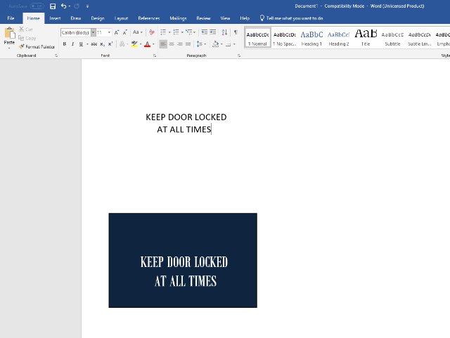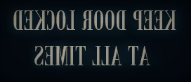

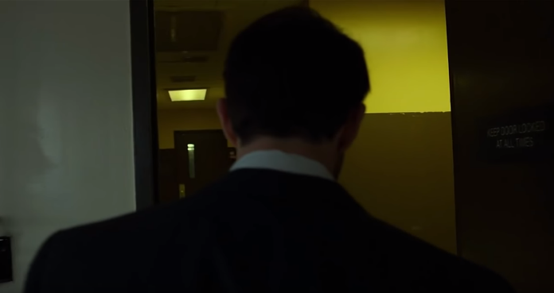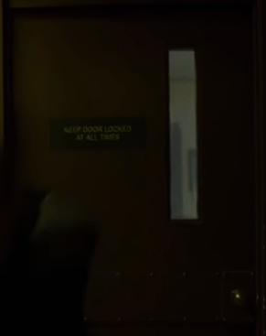

## Towel

To create the towel, I started off by adding a line into the scene and shaping it to look like a pinwheel or loop, I then extruded the line outward using the extrude modifier so that the line was in the shape of a towel. After the line was shaped like a towel I added the Shell modifier and adjusted the parameters to make the line thicker, then I went onto adding the noise modifier and started adjusting the strength of the modifier in the x and y-axis to make the towel look crumpled up. Finally, I added the turbo smooth modifier to make the edges of the towel smooth not robust.

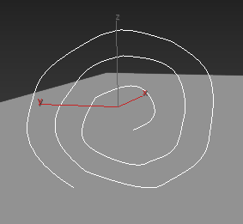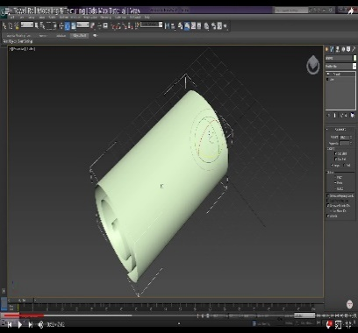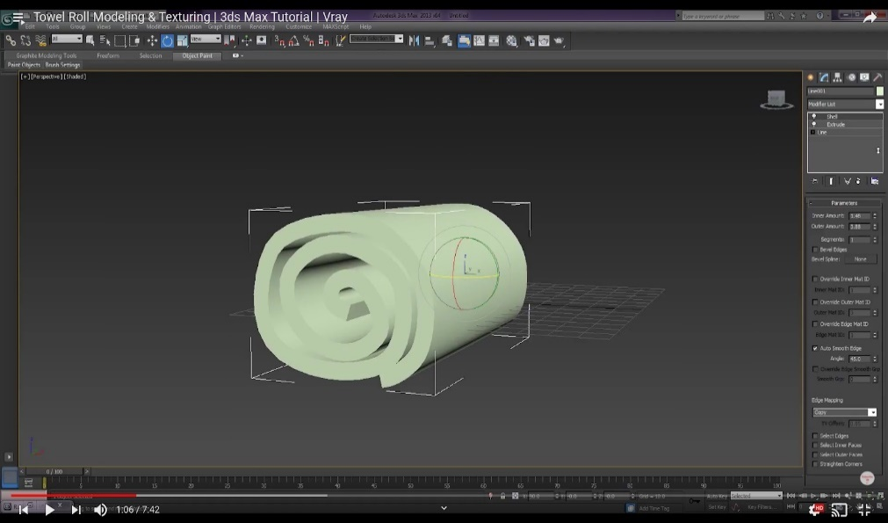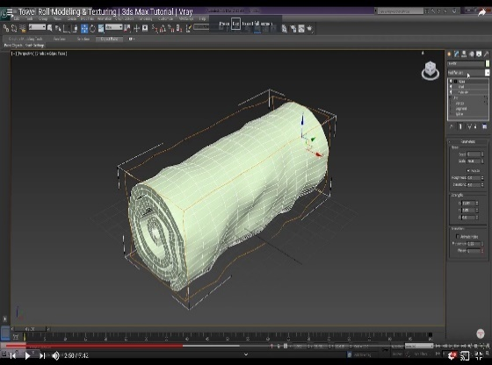

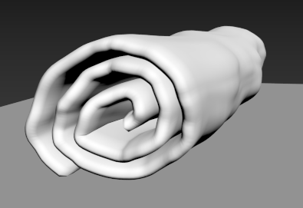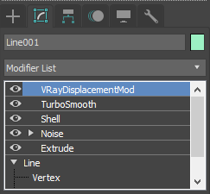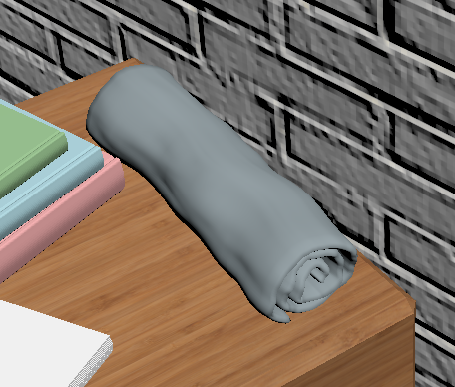

## Sink

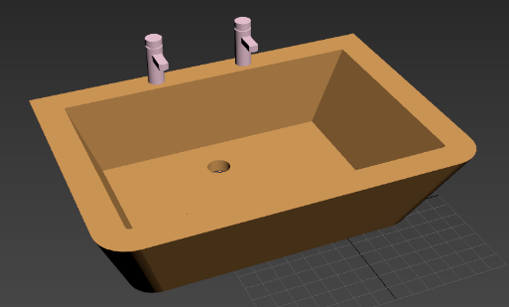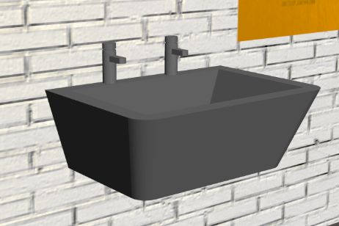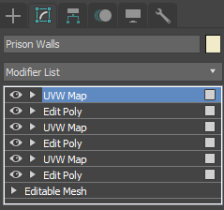

For the sink pipe, I first created a line and edited it, so it curved into the sink then I went on the modifiers clicked on enable in renderer and enable in viewport and finally changed the thickness of the line so that it resembled a pipe. I then added the metal texture to it.

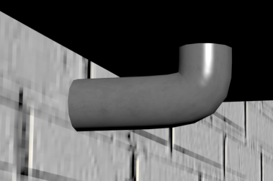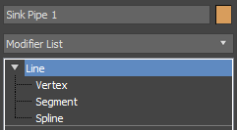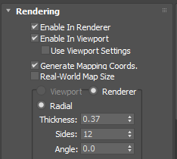

## Poster

For the posters I asked friends and family what posters would someone in prison have in their cell, I specifically wanted movie posters as I think that they will provide a sort of character background to the inmates that I will add in the animation project as the inmates respect and admire the characters in the movies I've chosen which are; The Silence of the Lambs, Prisoner of Alcatraz, The Godfather, Scar Face and Taxi Driver.

To create the posters, I added a plane into my scene then I opened the material editor selected an empty ID then clicked assign to material to make the plane the same ID as I was editing. I then selected maps went to diffuse map and selected bitmap and found the saved picture of the poster I had and pressed ok. Lastly, I turned the material on to show the picture of the poster on the plane. I repeated this step for all the posters and moved them into different rooms and placed them against the wall.

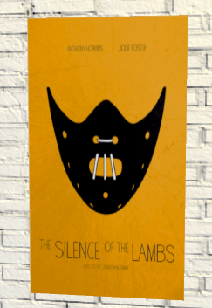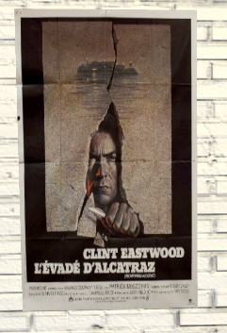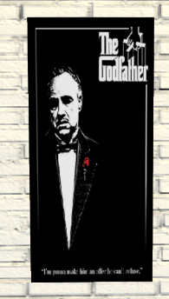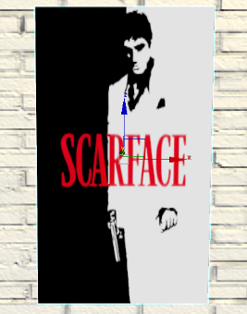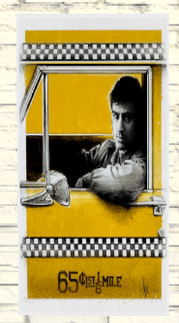

## Bed

For the bed frame I started off by creating a line in the shape of an arc I then changed the thickness of the line in the rendering drop-down menu. I then selected the top two edges of the arc and used the fillet tool under geometry to make the line curved. I then copied the bedpost and moved it to where the end of the bed will be and decreased the height of it using the scale tool. I then started creating more poles, rotating and moving them to form the bed frame. I then created a plane inside the bed frame and changed the length and width segments to 1. I then added the edit poly and scaled the plane to be the size I wanted and copied it several times moving it down the bed frame with each new plane. I then selected the whole bed frame and added the metal texture.

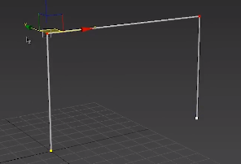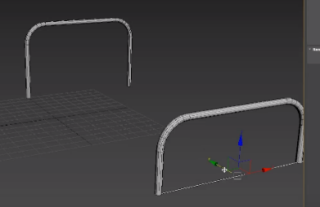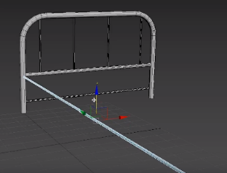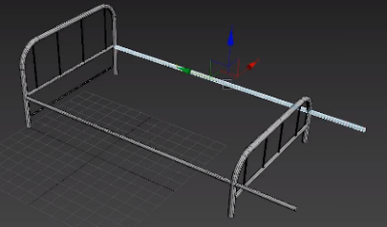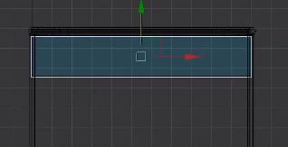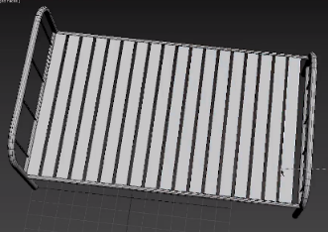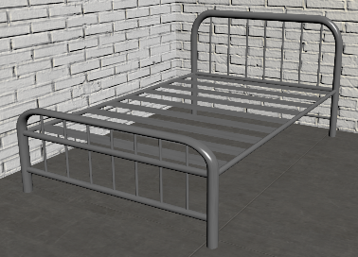

For the bed mattress, I started off by creating a chamfer box and added the turbo smooth modifier. I then added a plane to my scene above the box and then made it larger than it by using the scale tool. I then selected the plane and set the length and width segments 70 each. I then added a rectangle to my scene placing it around my plane and changed the thickness of the rectangle to be thicker than my plane. I then selected everything in my scene and added the cloth modifier, under the object menu I clicked object properties then removed the rectangle from the menu. then I made the box a collision object, I then selected the plane and clicked on the cloth option and loaded the cotton pre-set. I then clicked cloth, group and selected the edges of the cloth made them into a group and then clicked the node and then the rectangle to group them together. For the animation, I started by selecting autokey went to frame 8 selected the rectangle then moved it slightly down along the box and scaled it down a bit. Going onto frame 15 I moved the rectangle to be under the box and descaled it to be just wider than the box. Lastly, at frame 23, I moved the rectangle to be just under the box and scaled it in to be slightly smaller than the box. I then set the end frame to 30 frames. Finally, I simulated the animation and that's how I made my bed mattress cover.

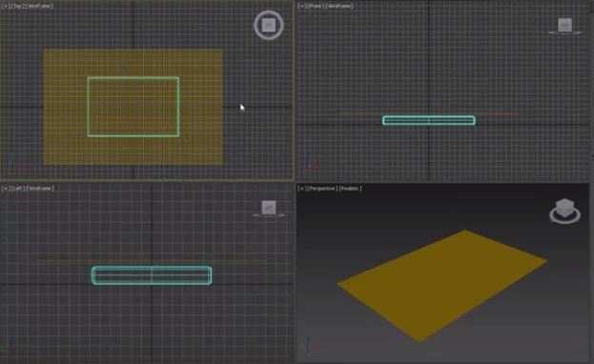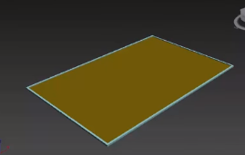

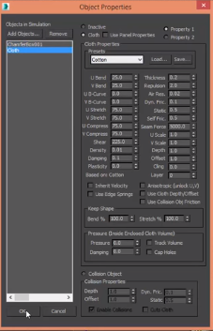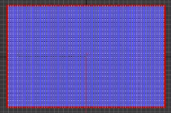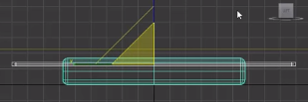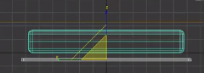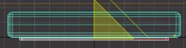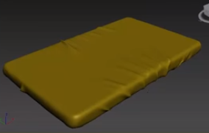

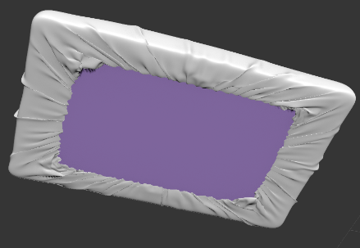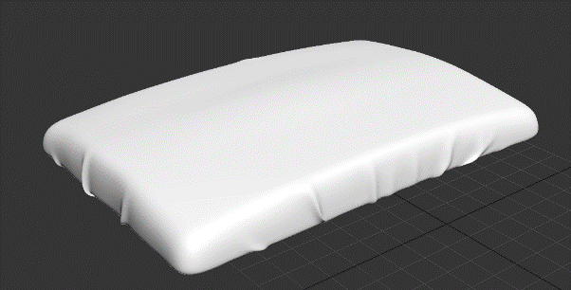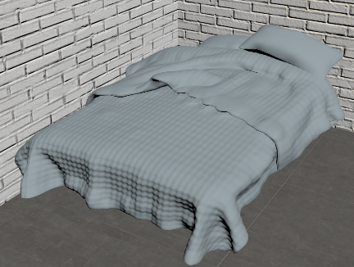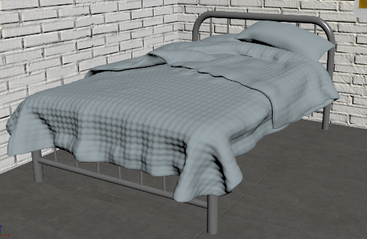

## Books & Paper

To create the paper, I added several thin boxes on top of each other to resemble a stack of paper. To create the books, I copied the stack of paper added the modifier edit poly to the whole stack added more vertices to the pages and then selected the vertices near the edge of the stack and indented it to resemble a book cover. I then selected the outer pages of the stack went on material editor selected a free ID and clicked assign material to selection. For the colour of the books, I changed the shader basic parameters to Blinn in the material editor and then using the colour more select in the diffuse heading I picked a primary colour for example blue and changed the saturation and whiteness of it to low.

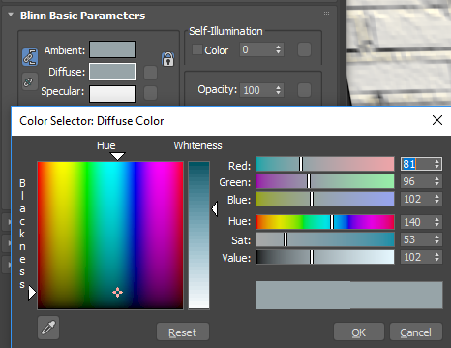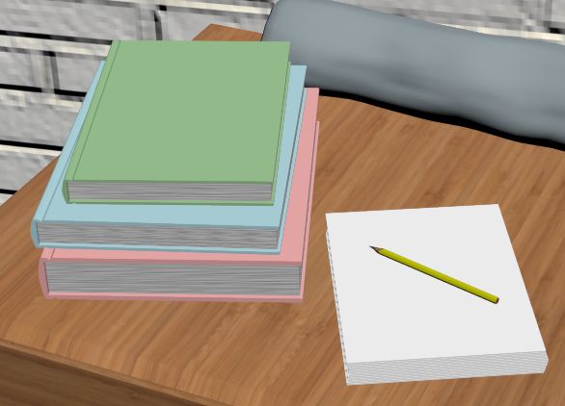

## Pencil

Firstly, I started off by creating a cylinder and adding the edit poly modifier, I then selected the bottom face of the cylinder and used the bevel tool within edit poly to create the point of the pencil. I then copied the cylinder and made it smaller using the scale tool and placed it inside the first cylinder and moved it forward to be the lead of the pencil. I then selected the first cylinder and started moving the faces on the end of the cylinder to look like the picture below. I then finished the pencil off by texturing the lead to be a dark grey colour, then I added a yellow colour to the pencils body. Lastly, I selected the distorted faces at the end of the pencil using edit poly and assigned the wood texture I used for the set of drawers to finish it off.

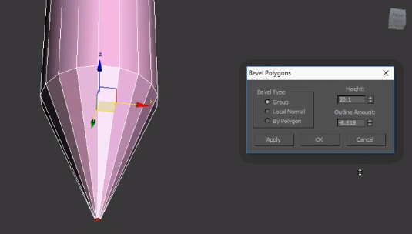

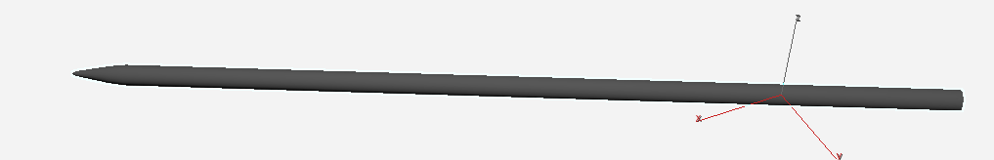

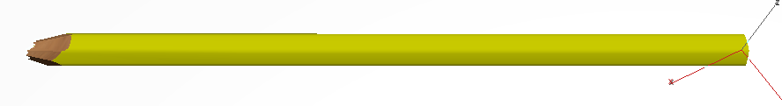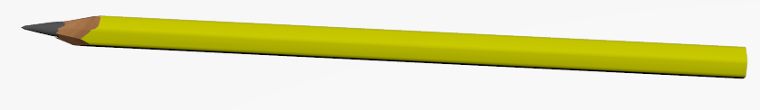

## Drawer

For the desk I started off with creating a box and adding the modifier edit poly selected the edges of the box and connected them, I then moved up the edge on the box using the move tool. Using the polygon select tool and clicked on the two front faces and inset them, then I used the extrude tool and moved the faces inward. Then I cloned the two faces and moved them outside the box. Using the edge tool, I selected all edges on the box and used the chamfer modifier within edit poly. To make the storage compartment I selected the lone face on the outside of the box and extruded it into the desk, I then selected the top face and extruded it inward. I then moved the box into the desk, for the second storage compartment I just cloned the first one and enlarged it. Finally, I applied a wood texture I found on CGTextures.com.

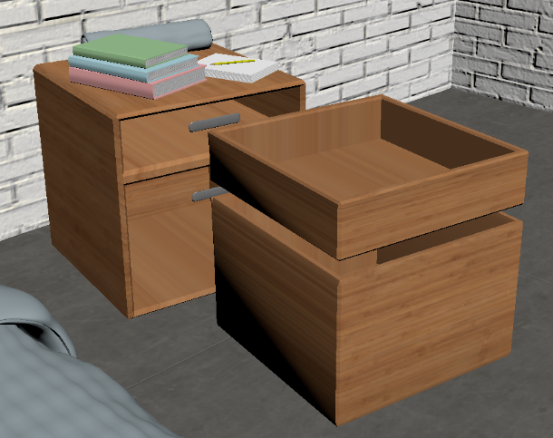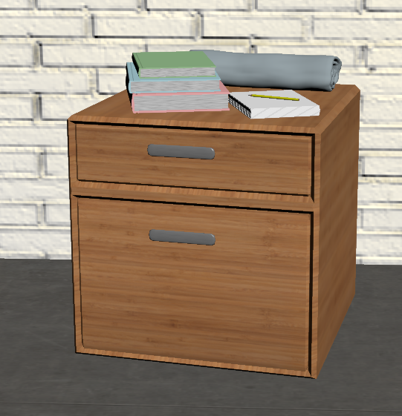

For the handles, I started by creating a box adding the edit poly modifier selecting the edges of the box connecting them and then moving the edges to the side of the box selectin the two new faces and extruded them outward. Then I added the mesh smooth modifier and textured the handle with my metal texture.

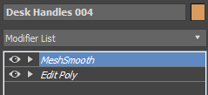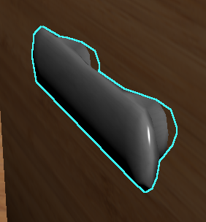

## Cell Bars & Door

For the cell bars, I started by creating the perimeter of the bars which is the metal cuboids for the I created a box and kept August the length, width and height to resemble the far-left bar you see. I then copied that bar 3 times moving and rotating it to create the perimeter. For the metal poles, I first created a cylinder and adjusted it to fit in the perimeter. I then added the metal texture and added the modifier UVW Map selected cylindrical fit and then fitted the texture, so it would work with the poles. I then made an array of the poles and adjusted it, so it looked realistic like the picture below. Finally, I copied the top bar 3 times and adjusted them to the location on the picture.

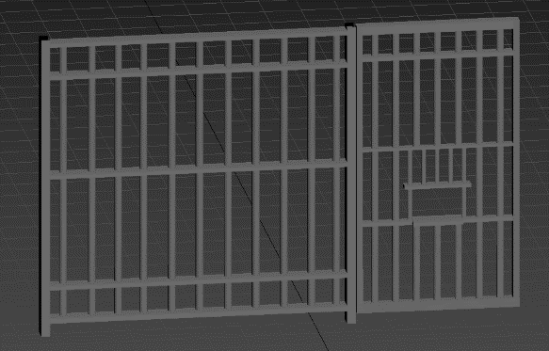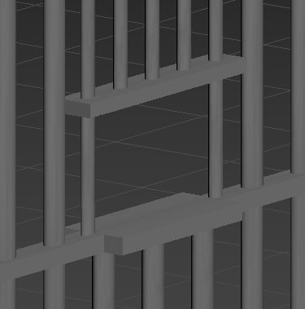

For the cell door, I found a reference picture and textured it onto a plane and started creating boxes and poles adjusting their size, rotation and location to match the reference picture. For the letterbox bit on the door where the guard would deliver the prisoners food through I just extruded the bars using the edit poly modifier.

<https://www.youtube.com/watch?v=glMN98klBPw>

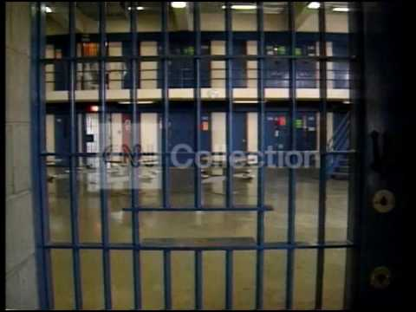

## Light Fixture

To create the light fixture, I started off by creating a line and shaping it to look like half of a light fixture and then using the lathe modifier which basically makes the line rotate 360 degrees while extruding to create a 3d model. I then added the metal texture I have been using on my other models but turned up the reflectiveness up a bit more, so the light would reflect off the fixture.

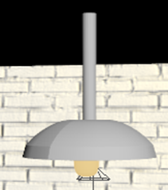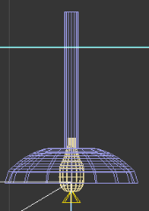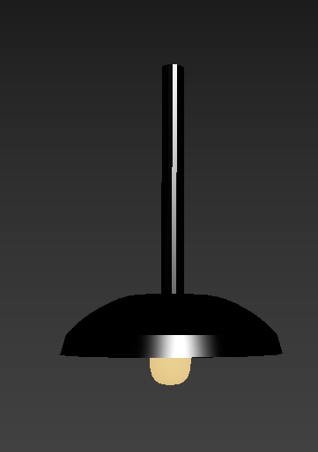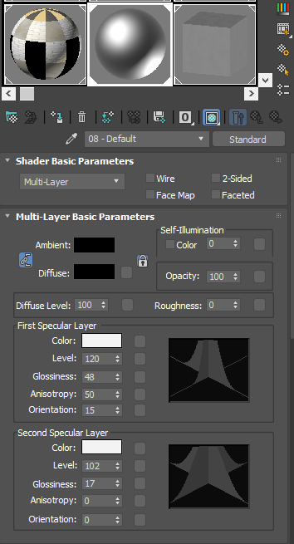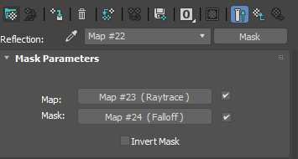

## Lightbulb

To create the light bulb, I started off by creating a line and shaping it to look like half of a light bulb and then using the lathe modifier which basically makes the line rotate 360 degrees while extruding to create a 3d model. I then went in the material editor and made a self-illuminating yellow colour and applied it to the bulb so that when I place a spotlight under the object it will illuminate behaving like an actual light.

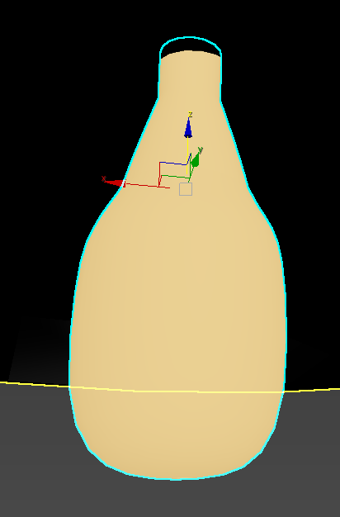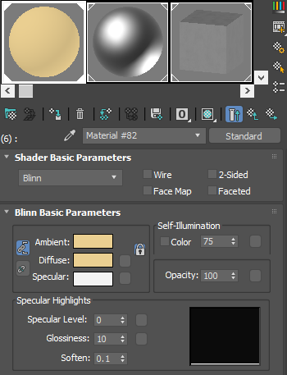

## Environment Lighting

I decided to go with dark lighting as it will be the most effective way of creating a dark and gloomy atmosphere. I did this by adding spotlights directly under the lightbulbs I made to make it seem like the lamps work. I then added Omni lights directly underneath the spotlights under the floor of my model and then halved the intensity of the Omni lights so that it would give the effect of light bouncing off the floor to light the rest of the room from the target spotlights.

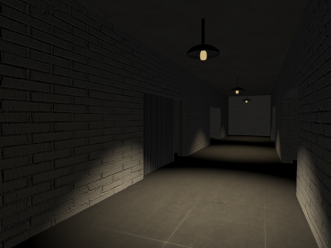

## Final Renders

For my final renders I decided to do two renders for each shot one with fog and one without as the fog changes the scene a lot and covers up a lot of the good texturing work. I would of also had made more renders however due to the poor hardware in my personal computer it takes up to 2 hours per render causing time constraints.

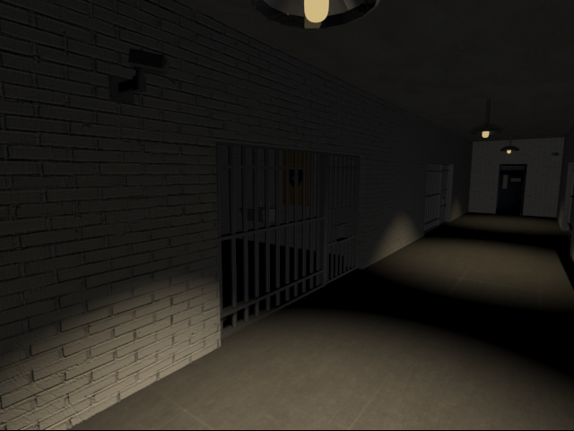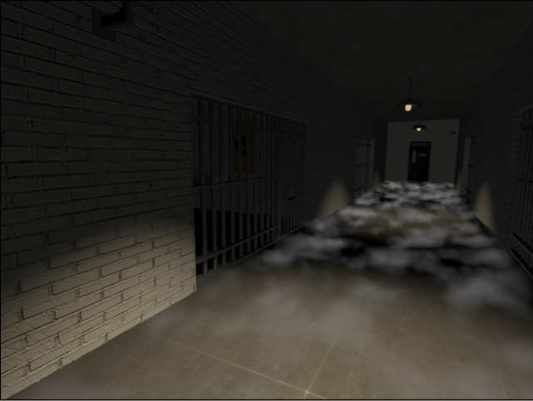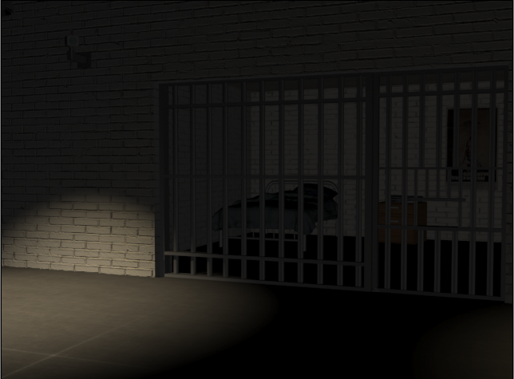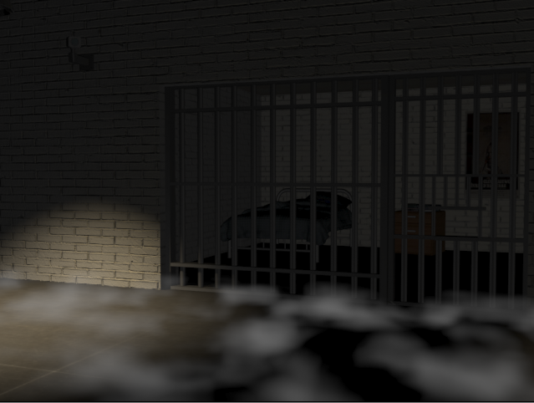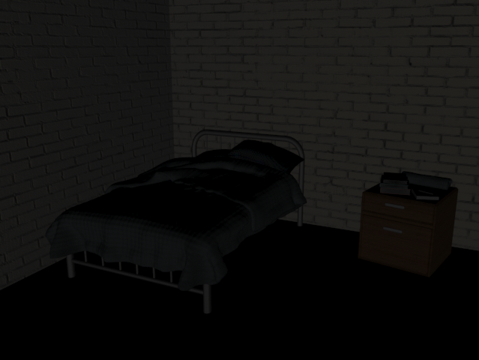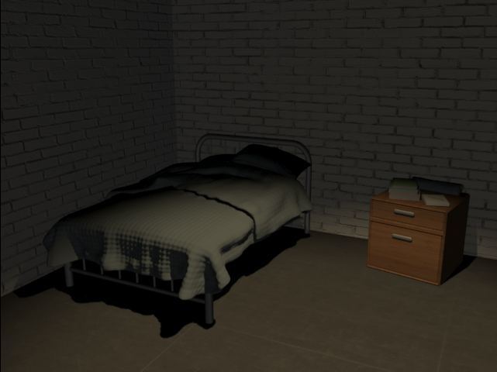

## Evaluation

During the creation of my environment, I had to watch out for the poly count in my project as if it was too high my project would take up too much storage meaning even longer rendering times. Professional game developers even have to keep their poly count low as to make sure the game is able to run as if an in-game character model had a high poly count it would make the game run slowly and may even cause it to crash. To keep my poly count low I started off by making the main body of my prison, for example, the walls, ceiling and floor have a minimal amount of polygons.

Overall, I am content with the 3D environment I have made, I believe it matches my concept art and I am happy with the end product. If I was to do the project from scratch and start over again a couple things I would do differently is do all my write up of how I made the models directly after I had made said model. I believe this would have helped my workflow and would have saved time as with this project I had to keep going back after my environment was complete to remember exactly what tools and modifiers I used to make certain models. I would have also kept making backups of my files as during this project some of my 3DS Max files got corrupted, so I had to remake my prison from scratch.